Task 3 Report

Naca Hitchman - 103072170

# Utility Functions

Firstly, as these functions will be plotting original downloaded finance data-frames, and not predicted data like the previous task, some code needs to be moved from the processData function from task 2 into their own separate functions. Specifically, the finance data downloading and file saving, as well as the data NANs processing.

By moving both into their own separate functions, we can re-use them for this task and still also call them in the original processData function. We can see below the data download code was moved into a new downloadData function, where we pass the ticker, dates, and whether or save file Boolean. Further, the NAN processing code was moved into a processNANs function, still retaining the ability to specify if NANs are to be dropped or filled. Both of these functions return dataframes so they can be used in other areas.

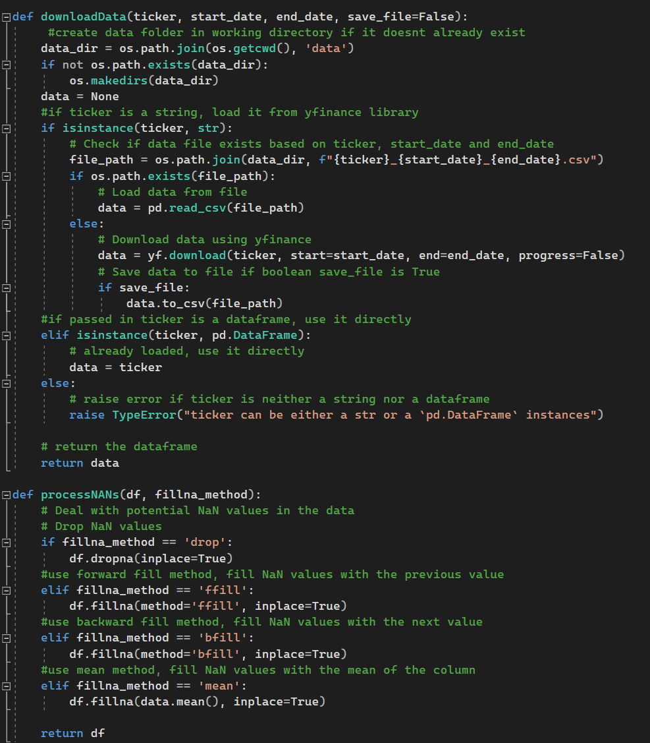

# Candlestick Chart Function

# Boxplot Chart Function